Alaska Indoor Gardening Curriculum

Starting Plants in the Classroom
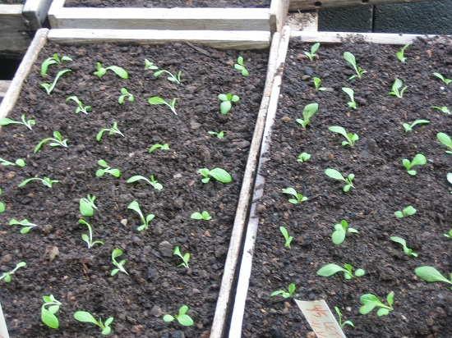
Author/Source: Patrick R. Ryan, Alaska Botanical Garden

Suggested Grade Levels: All

Time: 45 minutes for one session.

Teaching Goal:
To start greens, herbs and vegetables in the classroom for science and nutrition lessons. To grow transplants for outdoor gardening in the Spring, or indoor gardening with hydroponic setups.

Learning Objectives: Students will learn how to set up growing containers or seed flats, and about how to plant seeds.

Core Ideas:
- Reading and Comprehending Scientific Technical Information
- Horticulture
- Transplanting
- Hydroponics
- Plant Life Cycles
- Array Mathematics and Grids
- Germination
- Plant light and soil nutrient needs
- Standardized Science Measurements
- Science Journaling
- Recording Scientific Data in Tables
- Drawing Conclusions from Experimentation

Alaska State Science Standards: K-LS1-1, K-2-ETS1-2, 1-LS1-1, 2-LS2-1, 3-LS4-4, 4-LS1-1, 5-LS1-1, 5-LS2-1, MS-LS1-5, MS-ETS1-1, HS-LS1-2

NGSS Standards: K-LS1-1, K-ESS2-2, K-ESS3-1, 1-LS1-1, 2-LS2-1, 3-LS1-1, 3-LS3-2, 4-LS1-1, 5-PS3-1, 5-LS1-1, MS-LS1-5, MS-ETS1-1, HS-LS2-2, HS-ESS2-6,

Materials Needed:
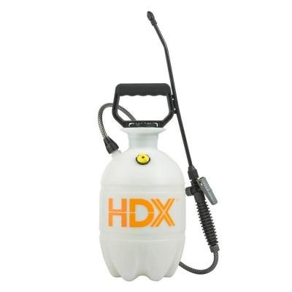
- Garden Soil – preferably a seedling mixture with perlite and peat and minimal bark chunks.
- Seeds, a wide variety of different types of seed packets
- seed flats (without holes) or any type of shallow planting containers including cookie trays, plastic salad containers, old baking pans, or shallow plastic storage containers (17 liter tubs).
- Plant Labels – popsicle sticks or other kind of plant tags
- Spray Bottles, a 1 gallon pump mist sprayer is a good option.
- shelves or counter space
- Grow Lights – T-5s or LED are best.
- Warmth – be sure the new seedlings are getting enough warmth. A cold windowsill is not the best place. Good lights can provide the necessary warmth as well as a consistently heated room.

Vocabulary:
- Annuals - Plants that perform their entire life cycle from seed to flower to seed within a single growing season. All roots, stems and leaves of the plant die annually.

- Biennials - Plants which require two years to complete their life cycle. First season growth results in a small rosette of leaves near the soil surface. During the second season's growth stem elongation, flowering and seed formation occur followed by the entire plant's death.

- Germination: Germination is the process by which the seeds begin to grow into the plant.

- Perennials - Plants that persist for many growing seasons. Generally the top portion of the plant dies back each Winter and regrows the following Spring from the same root system.

Background for Teachers: This lesson will explain how to plant and successfully grow seedlings indoors. Seeds need to be provided with consistent moisture, light and warmth for successful germination and growth.

Some seeds need light to germinate, others need darkness, but all seeds need moisture, oxygen and the right temperature to germinate. The usual temperature range needed for proper germination of seeds in a given soil type is about 41⁰ to 80⁰ degrees Fahrenheit (5⁰ to 26⁰ Celsius.) Once the conditions are right, the plant inside starts to grow and get bigger. It pushes open the seed coat, a bit like a chick hatching out of an egg. Tiny leaves appear and they push out of the soil.

The planting container is very important as well, it needs to be able to maintain the moisture, heat and air to assist the seeds in proper growth. Most seed flats are black to help retain the heat necessary for good growth. Red Solo cups are inexpensive and can work as individual planting containers. Small black or green square pots have holes and can fit in the flat better. The seed flat should be solid, with no holes. Stores sell both types: with holes and without holes.

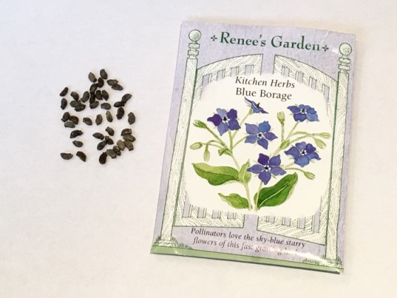
Follow the directions on the seed packet. Most seed companies offer good information right on the outside of their seed packets (or sometimes inside). See the lesson on “Reading a Seed Packet” HERE. Learn to read and understand the specific needs of whatever you’re planting BEFORE you get out into the garden. I recommend looking at your seed packets well before the suggested planting time in your area to familiarize yourself with that plant’s early growth requirements. If you have saved any seeds from the last growing season, they are probably good. Most seeds are viable up to 3 years. Onions, parsley, lettuces, larkspur and delphinium do not always carry over so they are best purchased fresh each year.

Here are the terms usually listed on a seed packet:
Plant Type:
On the front of the seed packet, it will tell you the type of plant as well as the variety or cultivar. For example: there is more than one kind of tomato and the variety is very important both for taste and hardiness. On flower seed packets it will also state whether they are an annual, perennial, or biennial. This could be important if you are planting the seeds for an outdoor garden as some plants can take multiple years to bloom.

Location, Sun or Shade
Most plants require 6 hours of sunlight daily. If starting seeds indoors, you will need additional light, usually 12-16 hours a day. A sunny south-facing windowsill generally does not provide sufficient light to grow strong seedlings, who need 12-16 hours a day of light. Artificial lighting is recommended.

Seed Planting Depth
A general rule of thumb is to plant the seeds twice as deep as their size. Cover if required and press down gently for good seed-to-soil contact.

Note: some seeds require light to germinate. “Some, but not all, popular seeds which prefer light for germination are: Achillea, Alyssum, Antirrhinum, Begonia, Calceolaria, Coleus, Exacum, Ficus, Gaiilardia, Gerbera, Gloxinia, Helichrysiim, Kalanchoe, Nicotiana, Petunia, most Primula, Saintpauliu and Streptocarpus.” (Source of article Growing From Seed - Spring 1989 Vol. 3 Number 2 © The Seed Raising Journal from Thompson & Morgan).
See also The New Seed Starters Handbook by Nancy Bubel for some great information on starting your own seeds.

Seed Spacing:
Sow small seeds thinly to give the tiny plants room to grow until they are strong enough to transplant to larger containers or into the garden. Generally, a one-inch spacing seems to work for the many greens that can be grown. Johnny’s Select Seed Company has some good information, geared at market growers.

Here’s an example from their Grower’s Library on sowing lettuce seeds: “Baby leaf lettuce: Sow in a 2–4" wide band, seeds roughly ½" apart, about 60 seeds/ft. Cover very lightly, about ⅛", and firm gently.” They are talking about direct sowing in the garden. In a container, sow the whole thing thinly and harvest baby leaves as they mature as a way to thin the plants. Most greens can be harvested by the “cut-and-come-again” method. Renee Shepherd suggests: “To harvest by the "Cut and Come Again, " method, cut with a scissors when lettuces reach about 4-5 inches tall to about 2” above the soil line. Water well and fertilize lightly to enjoy several additional cuttings.” You can also remove outer leaves from several plants for a quick salad.

Number of Days to Germination:
This is an approximate number. Seeds generally need to be kept moist while they are germinating, or “waking up”. If nothing green comes up after a week or so beyond the expected germination date, you may want to replant your seeds. Ed Hume Seed Company suggests some possibilities for poor germination: “Seeding too deeply, planting in cold soil, extremes of watering, improper soil preparation, birds or squirrels and poor seed are the most common causes for seeds failing to germinate.”

Date:
Look for the date of the seed packet, generally on the back or at the bottom. Remember that seeds are generally good for several years, although some varieties do not keep well. If the seeds have been kept cool and dry, they are generally okay to plant. If you have old seeds or if you have saved them from last year, you may want to test them first. Place ten seeds rolled up in a moist paper towel. Place in a small plastic bag and keep in a warm place. Check after a few days. If five or fewer seeds sprout, the germination rate is poor. If all ten sprout, that’s 100%, and you can plant those seeds and the ones in the packet.

Number of Days to Bloom/Harvest:
Somewhere on the packet it will tell you how long the plant will take to mature. This means a full blossom for a flower, or an edible fruit for a vegetable. This is an approximate number to help in your harvest planning. Weather, temperature, and watering can affect the time suggested. Seed catalog sites will suggest that if you are starting seeds indoors, you should count backwards from your last frost date to plan when your new seedlings can go outside into the garden or container. Johnny’s Select Seeds has a great planting chart. Just type in your last frost date here: www.johnnyseeds.com Look under: InteractiveTools_122014.
Many other seed companies have similar charts.

Height of Plant:
An approximate number for planning the height of a mature plant in the garden or a container. Generally , tall plants go on the back of the garden so they do not shade the smaller plants. In a container, tall plants would go in the middle if the container is to be viewed from many angles. This might be important for shelf spacing for indoor gardening to be sure the plants to push up against the shelves above them as they grow.

Procedure:
- Explain that you will be planting seeds today. Show the seed packets, and have the students sort the seed packets into the different types of plants you might grow. Go over how to read the seed packet and the requirements of each plant for growth that are located on the packet. Click HERE for the “Reading a Seed Packet” lesson.

- You may consider having students plant as individuals, pairs, or similar small groups depending on the space available. After grouping the students, explain to the class the requirements and limitations of growing in the room and ask them to select appropriate plants based on reading the seed packets. For example, perhaps you can’t accommodate plants that are taller than 5 inches or maybe you want to harvest the plants/send them home before the holidays. Explain this to the students. Each student or pair of students orally explains what plant they want to plant and why they think it’s a good choice for the project. Younger students and students without experience reading seed packets may need to watch the teacher model reading a seed packet before they make their selection.

- Choose suitable containers for planting seeds. You could have a selection available and model selecting and appropriate container for the plant you’ve chosen or have the entire class plant in the same type of containers. If the seedlings are to be transplanted into a garden (Spring) or to a hydroponic setup (all year), a commercial seed flat or recycled produce or deli tub is sufficient. If your goal is long term growing of plants (one semester), a larger tub for a greater depth of soil is appropriate.

- Next, the soil needs to be moistened. Model to the entire class how to wet the soil. First, place the approximate amount you’ll need into your tub and model slowly adding water and mixing it in. You may choose to provide measuring cups and standardized measuring tools as scoops so the students continue to develop familiarity with standardized measurement. The soil will be uniformly damp but not soggy or dripping with water when it’s ready. Dixie cups, water bottles, and other containers will work well for groups to use to wet the soil. Consider showing the students what the soil looks like when it’s a little too dry, just right, and too wet. After modeling, have groups retrieve the dry soil from a common area in the room and begin. Alternatively, you can prepare soil for the entire class before or during the lesson. Place all the soil in a large tub and add water slowly a small amount at a time. and mix until the soil is uniformly damp but not soggy or dripping with water.

- Students will add soil to the container to within one inch of the top. On seed flats, fill about ½ inch below the top. For the 17 liter tubs add about 4 inches of soil. When you add water, the soil will sink down a little. You don’t want it too shallow. Roots need room. Adding water to the soil BEFORE planting assures that the tiny seeds do not all wash into the corner of the tub. Smooth soil flat, sometimes tapping container on a flat surface can help with this process. Be sure to ask the students to check their soil with you and to wait patiently before beginning to plant their seeds. If you are choosing to use a science journal, this is a great time to have students who finish early begin journaling this process. See the Journaling Lesson HERE.

- In front of the whole class, model reading the seed packet. Point out where you found the information for how deep to sow the seeds and how to space the seeds. Sow the seeds according to packet directions. Generally, crops like lettuce, other greens and many herbs (small seeds) are sown THINLY over the top of the moistened soil, aiming for about a one-inch spacing. Again, groups that finish early may begin or continue journaling.

- Plant in a grid, but do not cover seeds until you have planted the whole container. Larger seeds can be planted in a one inch spacing using a grid pattern. Your students may be familiar with an “array” in math. For larger seeds make a hole with a pencil as deep as the sharpened end. Then cover lightly with soil, very gently tamp down the new soil. Lightly water with the sprayer or mister again. This will assure good “seed-to-soil contact” for proper germination.
- Place containers under lights, and cover with a clear lid or plastic wrap if possible, until the seeds sprout. You can also add bottom heat with a commercial heat mat, but the seeds will grow without these two steps.
- Have students take turns watering the trays daily, to keep soil moist but not soaked. Light sources should be turned on and off manually to match the recommended daylight or set on timers to mimic day and night. For leafy greens a 12 hour on and 12 hour off cycle is best.
- Once the second set of leaves emerges, fertilize the plants with a good leaf fertilizer. Read the package for directions so you do not over fertilize. More fertilizer than what is recommended is not a good idea and can often cause death of your seedlings.
- Continue growing until large enough to harvest, as suggested by the seed packaging or transplant the seedlings into larger pots or into the school garden. Students could also be allowed to take them home.
- If harvesting at school, plan a day to harvest and share the leafy greens in a salad or conduct a taste test.
- After the class has finished planting and you are satisfied with their progress, close the lesson by reviewing the following concepts:
  - To grow plants from seed, you need to have light, warmth, and water.
  - It is important to know the details about each plant, how deep to plant the seed, how long the plant will take to mature, how far to space the seeds, etc.
  - Consider asking the students what they learned, what was different than they expected, and about what they liked or disliked. Also, consider providing additional time to journal to groups and individuals who need it.

Worksheets: Plant Growth Monitoring Chart

Extensions:
- Indoor Lighting Systems Handout (for setting up your system)
- Seed Science Lesson
- Do You Know the Parts of Plants? Lesson
- Individual Plant Parts Lessons
- Reading the Seed Packet Lesson

Cross Curricular Ideas:
- Ask students to estimate how many seeds they planted in total based on multiplication arrays. How many did a group plant, an individual (half a group), the entire class, etc.
- Ask the students how many plants will grow (after doing the above estimation) if 20% of the plants germinate, 50%, 75%, etc.
- Use standardized measuring tools like tablespoons, measuring cups, pint containers, etc. to scoop soil and water and talk about this.
- Explicitly teach the vocabulary including the prefixes, suffixes, and roots of the gardening words
- Read aloud one of the books (ideas below) and use in a reading center
- Expand the journaling prompts into a writing assignment
- Discuss the plants that grow in their local area and the limitations that outdoor gardeners may face. Ask students what local gardeners may be looking for as they seed shop.
- Design a seed packet for a “new” plant that contains some of the information they learned about in the day’s lesson. This can be oriented as an artistic opportunity or more of a writing opportunity. But there’s a lot that can be done!

Assessment Options:
- Strong, vigorous plants will be a good measure of success.
- Write a paragraph(s) explaining the process someone should use when planting a seed.
- Give students requirements and limitations in a different environment and ask them to choose seeds that may meet the requirement and explain why they chose those seeds.
- Ask students to make predictions about what will happen next. The predictions should be based on information from the seed packet they planted.
- Evaluate their journal entry. Journal entries vary by grade level and class expectations. But you could consider having the students write a sequence of events, self-evaluation, and sketch of their finished container.
- You could develop a checklist and check off when students or student groups successfully complete parts of the lessons. For example; choosing an appropriate plant, moistening the soil, spreading the seeds, journaling, behaving appropriately, clean-up, etc.

References:
Books:
A Seed Is Sleepy by Dianna Hutts Aston, illustrated by Sylvia Long
ISBN-10: 0-8118-5520-1; ISBN-13: 978-0-8118-5520-4 2007

From Seed to Plant by Gail Gibbons
ISBN: 0-8234-1025-0 1991

Gardening Indoors with Soil and Hydroponics by George Van Patten
ISBN: 978-1-878823-32-8

How a Seed Grows by Helene J. Jordan, illustrated by Loretta Krupinski
ISBN-13: 978-0-06-445107-9; ISBN-10: 0-06-445107-0

Websites:
KidsKonnect – General Gardening information
https://kidskonnect.com/science/gardens/

Johnny’s Selected Seeds Growing Center Information
http://www.johnnyseeds.com/growers-library/growing-center.html

Kids Gardening
https://kidsgardening.org/

Renee’s Garden Resources
https://www.reneesgarden.com/blogs/gardening-resources

Good information on using recycled produce or deli containers for seed starting:
http://reneesgardenseeds.blogspot.com/2014/03/easy-seed-starting-using-recycled.html

Really Useful Box (17 Liter with lid).
http://www.reallyusefulproducts.co.uk/usa/html/onlineshop/rub/b17_0litreUS.php
NOTE: Drill holes in the bottom of these boxes and then use the lid on the BOTTOM of the tub to collect excess water.

Seed Germination Handout
Name: Date:
The following handout will aid you in recording information on your seedling and its growth progress. Please read over each section and complete the information as completely as possible.

Seed:
Describe the environment in which you will be sprouting the seeds, be sure to include physical characteristics (container, growing medium) as well as environmental (temperature, humidity):
____________________________________________________________________________________________________________________________________________________________

What type of seed have you chosen? Please describe its growing characteristics (time for germination, light and moisture requirements):
____________________________________________________________________________________________________________________________________________________________
Germination
Please chart your seeds’ germination date. A place is provided for you to provide a sketch of what your seedling looks like.
Seed Name/Type | Date First Sprout Detected | Date First Leaf Appears | Draw Seedling

